# DAD 220 Module Three Major Activity Database Documentation Template

## Overview

Complete these steps as you work through the directions for this activity. Replace the bracketed text with your screenshots and brief explanations of the work they show. Each screenshot and its explanation should be sized to approximately one quarter of the page, with the description written below the screenshot. Follow these rules for each of the prompts and questions below. Review the example document for help.

## Create a Database

1. In your integrated development environment (IDE), **create a database schema** called QuantigrationRMA. List out the database name. Provide the SQL commands you ran to successfully complete this in your answer, then connect to it:

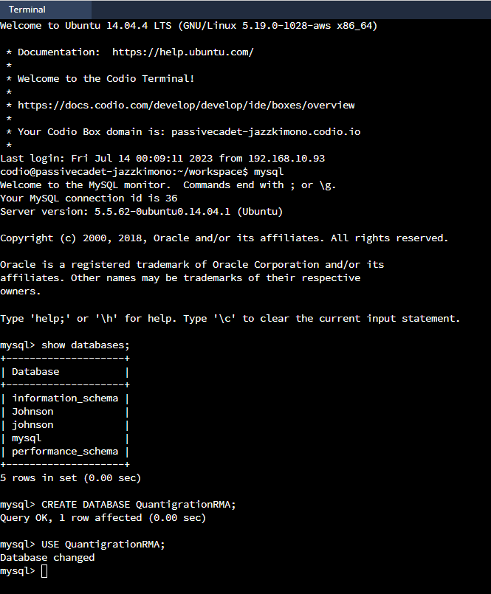

As seen above, I entered the codes: **CREATE DATABASE QuantigrationRMA;**

**USE QuantigrationRMA;** to successfully create a database schema.

1. Using the entity relationship diagram (ERD) as a reference, **create** the following **tables with the appropriate attributes and keys**:
   1. A table named **customers** in the QuantigrationRMA database as defined on the project ERD. Provide the SQL commands you ran against MySQL to complete this successfully in your answer:

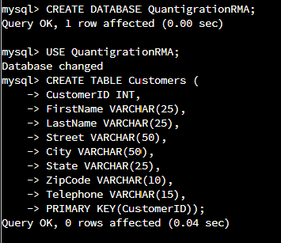

In this screenshot, the customers table was created using: **CREATE TABLE Customers (**

**CustomerID INT,**

**FirstName VARCHAR(25),**

**LastName VARCHAR(25),**

**Street VARCHAR(50),**

**City VARCHAR(50),**

**State VARCHAR(25),**

**ZipCode VARCHAR(10),**

**Telephone VARCHAR(15),**

**PRIMARY KEY(CustomerID));**

* 1. A table named **orders** in the QuantigrationRMA database as defined on the project ERD. Provide the SQL commands you ran against MySQL to complete this successfully in your answer:

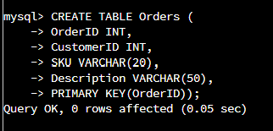

The orders table was created using: **CREATE TABLE Orders (**

**OrderID INT,**

**CustomerID INT,**

**SKU VARCHAR(20),**

**Description VARCHAR(50),**

**PRIMARY KEY(OrderID));**

* 1. A table named **rma** in the QuantigrationRMA database as defined on the project ERD. Provide the SQL commands you ran against MySQL to complete this successfully in your answer:

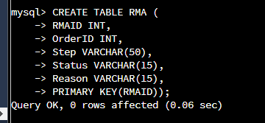

Finally, the RMA table was created using: **CREATE TABLE RMA (**

**RMAID INT,**

**OrderID INT,**

**Step VARCHAR(50),**

**Status VARCHAR(15),**

**Reason VARCHAR(15),**

**PRIMARY KEY(RMAID));**

1. Manually **add 10 records** into the **Customers table**. The data can be made up for now, as you you’ll populate all three tables later from the provided CSV files.

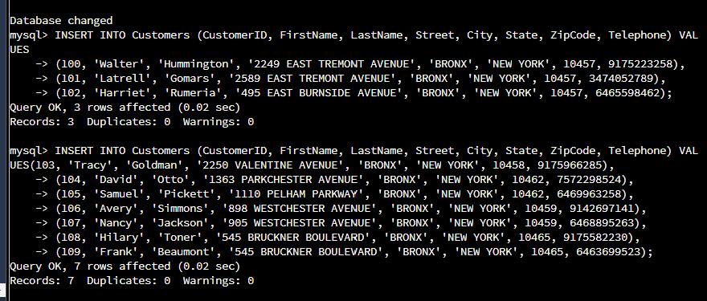

Ten records were added using: **INSERT INTO Customers (CustomerID, FirstName, LastName, Street, City, State, ZipCode, Telephone) VALUES.** Then, **(100, 'Walter', 'Hummington', '2249 EAST TREMONT AVENUE', 'BRONX', 'NEW YORK', 10457, 9175223258),** was added after many errors. I had trouble with the syntax, but was able to become successful.

1. Create a view from the **existing Customers table** by using the SQL command provided belowto say "Collaborators." The view should show all instances of "Customer" renamed as "Collaborator."

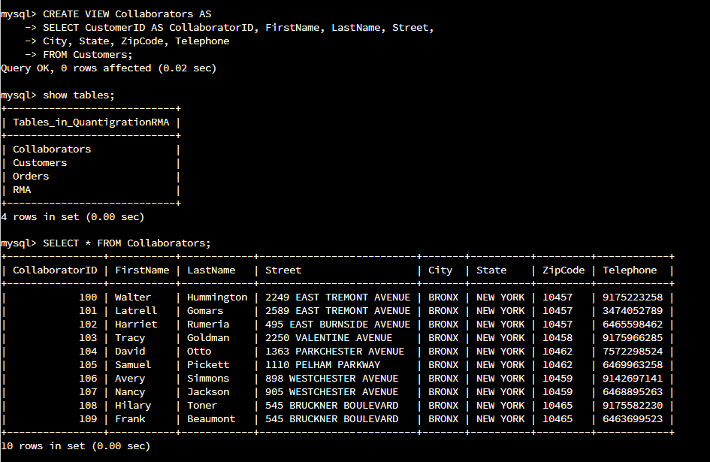

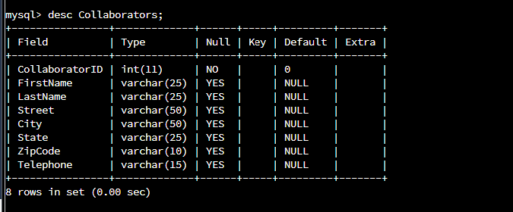

The two screenshots display the final result of renaming the customers as collaborators. The Customer ID was renamed as Collaborator ID as seen above.